**PIZZA SALES SQL QUERIES**

1. **KPI’s**

**1. Total Revenue**

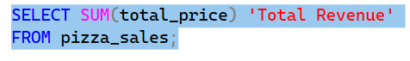



**2. Average Order Value**

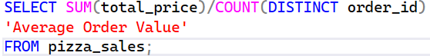



**3. Total Pizzas Sold**





**4. Total Orders Placed:**





**5. Average Pizzas Per Order:**

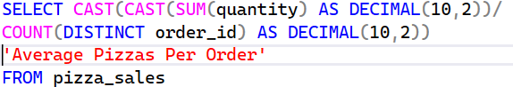



1. **Daily Trends For Total Orders**

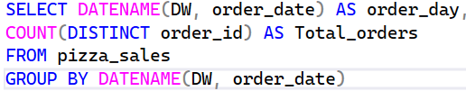

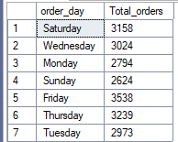

1. **Monthly Trend For Total Orders**

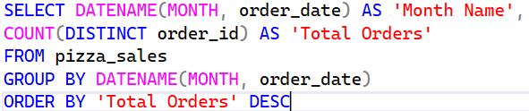

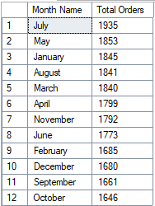

1. **% of Sales By Pizza Category**

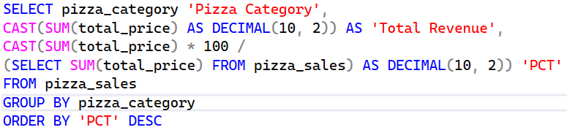

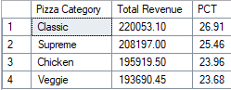

1. **% of Sales By Pizza Size**

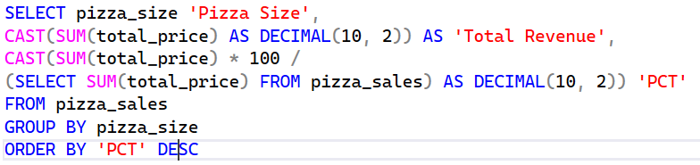

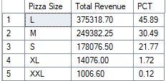

1. **Total Pizza Sold By Category**

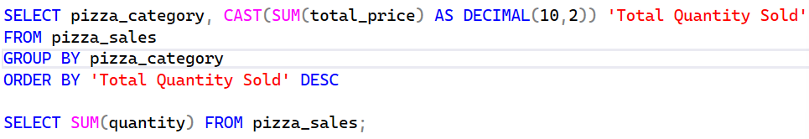

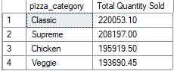

1. **Top 5 Pizzas By Revenue**

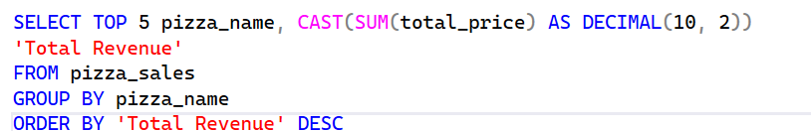

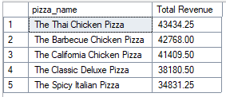

1. **Bottom 5 Pizzas By Revenue**

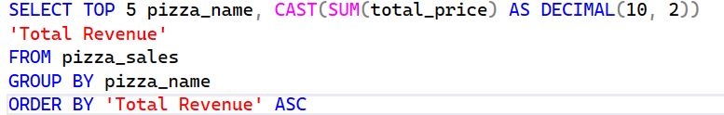

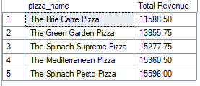

1. **Top 5 Pizzas By Quantity**

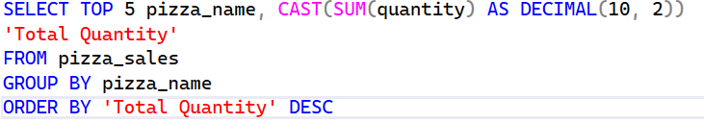

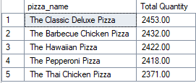

1. **Bottom 5 Pizzas By Quantity**

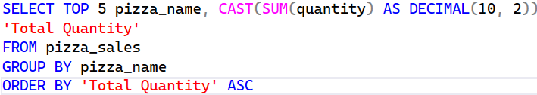

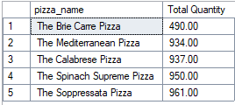

1. **Top 5 Pizzas By Orders**

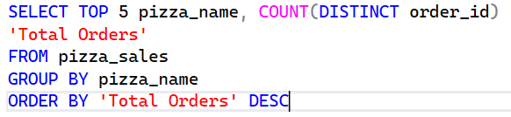

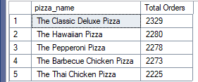

1. **Bottom 5 Pizzas By Orders**

